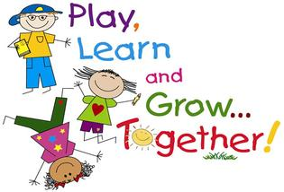PreK Supply List
RRVCS 2022-2023

- 1, 1” 3-ring binder (clear pocket in front/back)
- 1, washable markers
- 2, glue sticks
- 1, children’s scissors
- 1 pkg., playdough (any colors)
- 2, Kleenex boxes
- 1, toothbrush/toothpaste (we will be brushing after lunch each day) *No electric toothbrushes please!
- 1 pkg., gallon zip lock bags
Rest Time
Children will have Rest Time each afternoon on cots. Bedding will be sent home every 2 weeks to be washed. (unless needed each week due to sickness) Please send a reusable “grocery” bag to take items back and forth from school to home.

- Fitted crib sheet
- Small pillow
- Small blanket

Extra items needed in PreK
Remember to Label your child’s items!

- Water Bottle (With straw/flip top if possible to reduce spills)
- Change of Clothes (underwear, pants, shirt, socks) *In case of accidents/messy activities
- Old pair of shoes (can be slip on to wear in classroom for messy activities or when wearing snow boots at recess)
- Snow boots, snow pants/bibs, waterproof gloves and jacket *WILL NEED LATER IN SCHOOL YEAR
Additional Items
OPTIONAL but VERY MUCH Appreciated!!
- Disinfecting wipes
- Copy paper
- Donated Items: toys, stuffed animals, clothes/props/kitchen items for dramatic play area, outdoor toys such as old cars/trucks/sand toys/balls/games.

